
Logging into the Phone Queue

Definitions of Color on Pre-Function Key #4 for Queue:
- Solid Red: Not Logged In
- Solid Orange: Only 1 Person Logged In
- No Color: Multiple People Logged In
- Flashing Red: Not Accepting Calls

Logging into the Queue:
- Press and hold the #4 Pre-Function Key (PFK) for five seconds. The login prompt will appear. Release the button.

- Agent’s extension should show on the login screen. Select OK

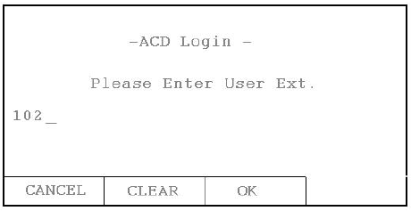

- Select the queue you want to log into. If there is only one queue assigned to the agent, this step will automatically be skipped. Select the queue by using the up/down arrows and the checkmark. When complete, select OK.

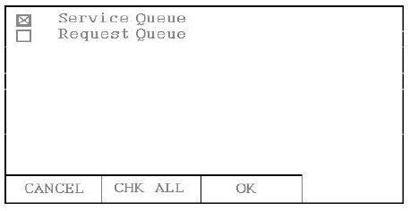

- You will be prompted to enter the agent’s password. Note: Password is the same as your voicemail password. Once complete, select OK.

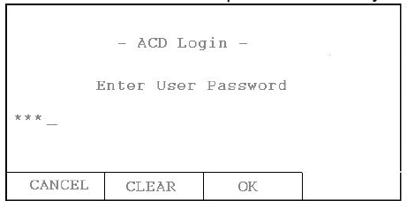
- To log out, press and hold the PFK for five seconds. The ACD queue list is displayed. Deselect the queue, enter the agent password and press OK.

Note: If you miss a call you will be temporarily “logged out” of the queue. The PFK key will begin flashing red. To begin taking calls again you must press the PFK key once.

