Accessing Email Through the Internet
You can access email in any internet browser, but it works best in either Google Chrome or Firefox
- Go to: outlook.office365.com

- Your login information will be:
  - email address (username@aimhealthy.org)
  - Windows Password

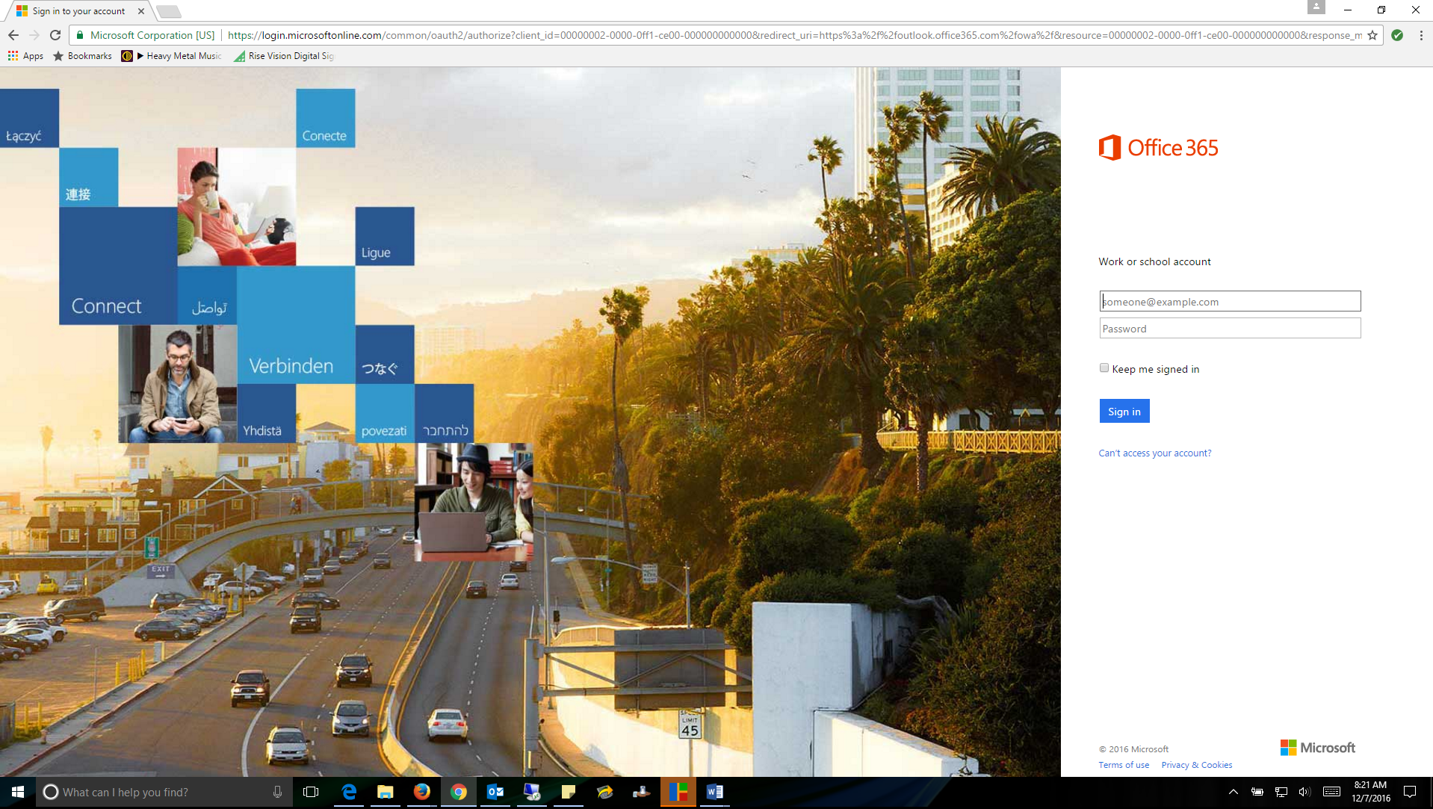

You can still access the above log in page by going to the Intranet homepage and clicking the Outlook Webmail icon.

